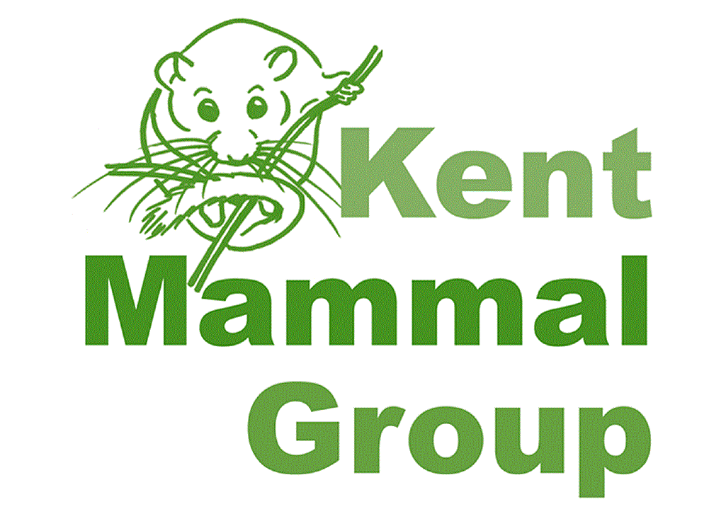
Kent Mammal Group: Grant Application Form
Grant application guidance and conditions
- Applicants must be a member of Kent Mammal Group in order to be eligible to apply for grant funding.
- If the applicant is currently a student at a UK Higher Education institution, then the Student Grant Application Form should be used.
- Research/projects must aim to improve understanding of wild mammals in Kent. Applications are especially welcomed in relation to research which aims to contribute towards conservation of Kent’s mammal species.
- Recipients of a Kent Mammal Group grant will be required to write a brief report (500 words max) summarising the main findings of their research. This may be selected for publication on Kent Mammal Group’s website or in the biannual newsletter, Quadrapedia. Recipients will also be invited to give an optional presentation on their research findings at a Kent Mammal Group meeting.
- Any equipment obtained using this grant must be offered back to the Kent Mammal Group once the proposed research has been completed.

Name of applicant
Organisation (optional)

Title of proposed research project
Outline of proposed research
When will the work be undertaken? (Please provide an indication of when project work will be completed).

Amount of funding being applied for (max. £250)
Reason(s) for application (include a breakdown of how funds will be used)
How does the research benefit knowledge and understanding of mammals in Kent?

Has funding been sought from any other organisation(s) for the project stated above? If so, please provide further details.

Signature of applicant
Date signed

