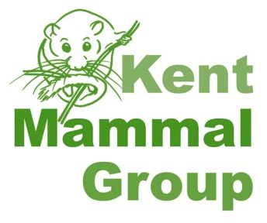

Dormouse Training Programme

Kent Mammal Group (KMG) are running dormouse training workshops at Wildwood for volunteers who would like to help monitor a dormouse site for KMG.

The Dormouse Ecology and Conservation course is offered at a special discounted price of £30 for KMG members (you can join on the day if you are not already a member) who are prepared to train for a dormouse licence with KMG and then monitor a site for KMG for a minimum of one year. Training time varies depending on the number of dormice found during site visits and your individual competence. Be prepared to train once per month for at least 2 survey seasons.

To obtain your licence you will also be expected to attend a Dormouse Handling Workshop which will also be offered to KMG members at a discounted cost of £20. If you are unable to attend these dates we do offer similar courses on other dates at full price. These would still count towards your training with KMG. Please contact courses@wildwoodtrust.org for further details.

Once you have attended the courses and agree to the KMG training scheme you will be allocated a training site. The location depends on availability but we will try to find one close to where you live.

You will also be required to keep a training log (see attached) which is based on recommendations from PTES and Natural England. This is useful when applying for your licence. Once your trainer feels that you are competent to work under your own licence you will be assessed by another licensed surveyor and 2 references will be supplied for your licence application.

